# Cybersecurity

## Activity 1.1.2: Password Protection and Authentication

Copy and paste screenshots and/or answer questions from the activity.

#5 Screenshot of Power Settings

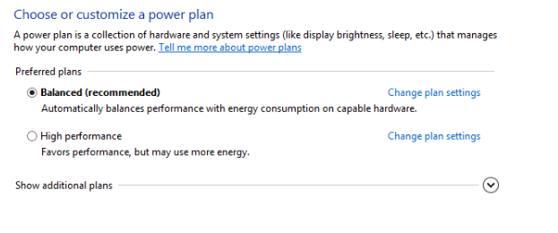

#12 Screenshot of Directory Files

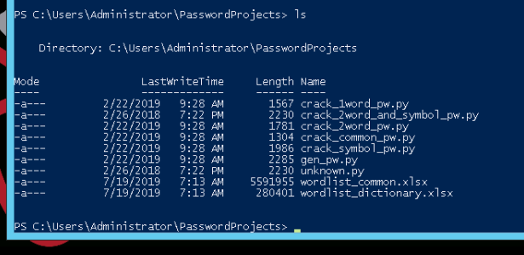

Use the following table for the Algorithm 1 Section through the end of Activity 1.1.2

|  |  |  |  |
| --- | --- | --- | --- |
| **Algorithm** | **Password** | **Guesses** | **Time** |
| 1: Crack one word | Explore | 6576 | 0.001 |
| 1: Crack one-word (beginning) | Alpha | 572 | 0.0001 |
| 1: Crack one-word (end) | Zootopia | 21387 | 0.004 |
| 2: Average one-word |  |  | 0.0017 |
| 2: Crack one-word and symbol | Apple? | 52673 | 0.0216 |
| 2: Crack one-word and symbol | Dog? | 33215 | 0.0127 |
| 2: Average one-word-symbol |  |  | .01715 |
| 3: Crack one-word many symbols | Dog& | 321051 | 0.11 |
| 3: Crack one-word many symbols | Zebra= | 1236711 | 0.44 |
| 3: Average one-word many symbols |  |  | .275 |
| 4: Crack two-word | Bridgebuilder | 54560925 | 28.517 |
| 4: Crack two-word | damdigger | 104095867 | 54.25 |
| 4: Average two-word |  |  | 41.38 |

#13 Screenshot

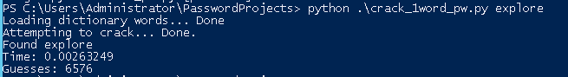

#16 Screenshot

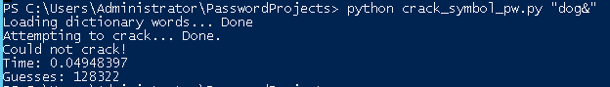

#21 Screenshot

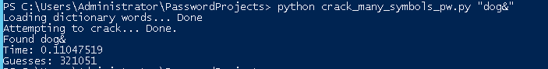

#23 A: 10x longer

B: 2300x longer

C: Stronger

D: More Symbols / Words

#24 Screenshot



#25 Summarize why a passphrase like Purple#Hopscotch&is4me is better than purplehopscotch. Look back over your data and explain your answer in terms of the data you collected.

It contains unique symbols at various points in the password